Document Title

Table of contents
1 How to extract physical registry files 3
1.1 Extract registry files using WinHex 4
1.2 Extract registry files using Encase 6
2 Low level structure of the registry hive files 7
2.1 General file layout 8
2.1.1 Header page 8
2.1.2 Hive pages 9
2.1.3 Hive data 9
2.1.4 Keys and values 9

How to extract physical registry files
The live registry files are in constant use by the operating system, therefore you are not able to access it from file system level. You can access to the registry files using:

- WinHex - application is available at www.winhex.com
- Encase

Extract registry files using WinHex

Step 1 – Open Logical Drive C:

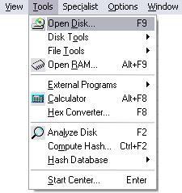

Press F9 or click Open Disk…
from menu Tools
…or click on tool bar icon
…and select drive C:

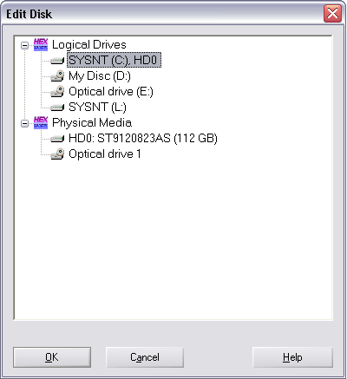

Step 2 – Go to registry folder C:\WINDOWS\system32\config

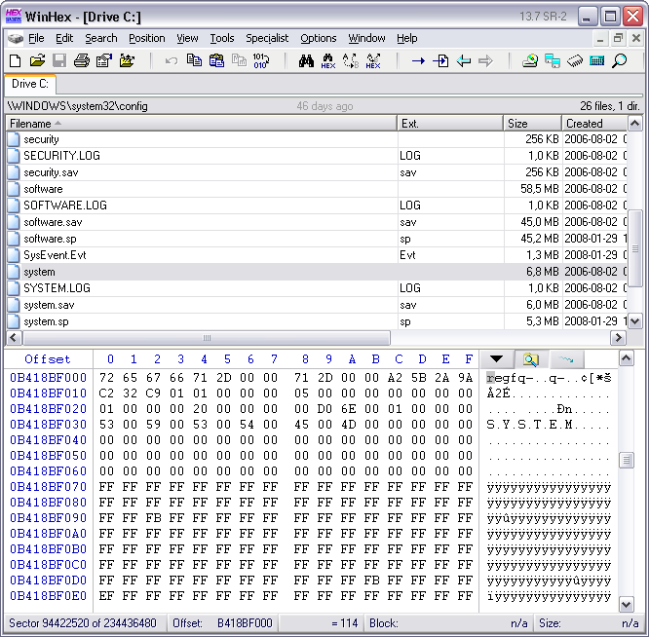
Hex view of selected registry file
List of files in current directory

Step 3 – Extract file using Recover/Copy… function.

Use right-click to open context menu and click Recover/Copy…
to extract selected file.
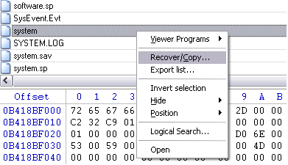

Extract registry files using Encase

Low level structure of the registry hive files
Registry files, like almost every kind of data stored in files have its own layout. Every single file containing registry data is called Registry Hive.

General file layout

- Header page
- Hive pages
- Hive data chunks
- Keys and values

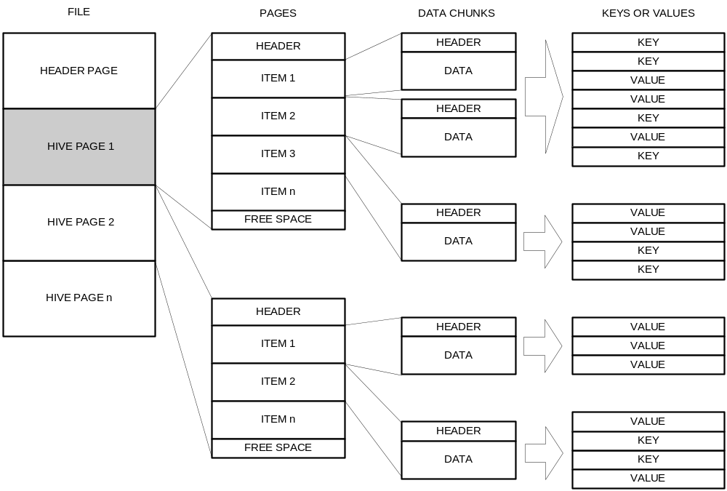

Structure signatures - magic numbers

Every structure used in registry files has its own signature. All data signatures are called magic numbers.
The main purpose and advantages of magic numbers are:

- Distinguish structures with common structure layout.
- Allows to recognize type of the structure
- Easy to spot using hex editor

Following table contains list of all magic numbers used in registry hives:

Magic Numbers
# | text | hex | description
1 | regf | 0x66676572 | Header page
2 | hbin | 0x6E696268 | Hive page
3 | vk | 0x6B76 | Key value
4 | nk | 0x6B6E | Node key
5 | lh | 0x686C | Hash leaf
6 | sk | 0x6B73 | Security key
7 | lf | 0x666C | Leaf key

Example of magic numbers

Following screen shots presents magic numbers used in system registry hive.

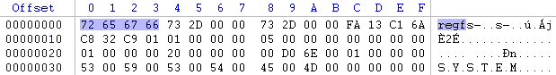
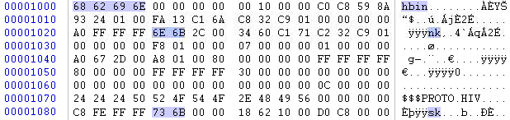
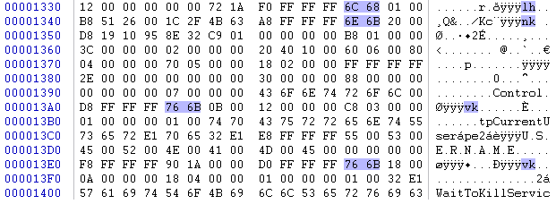

Header page

Hive pages

Hive data chunks

Keys and values

Value Types
Id | Value name | description
0 | REG_NONE | No value type
1 | REG_SZ | Unicode null terminated string
2 | REG_EXPAND_SZ | Unicode null terminated string with environment variable references
3 | REG_BINARY | Free form binary
4 | REG_DWORD | 32-bit number
4 | REG_DWORD_LITTLE_ENDIAN | 32-bit number same as REG_DWORD
5 | REG_DWORD_BIG_ENDIAN | 32-bit number (big endian)
6 | REG_LINK | Symbolic Link Unicode
7 | REG_MULTI_SZ | Multiple Unicode strings
8 | REG_RESOURCE_LIST | Resource list in the resource map
9 | REG_FULL_RESOURCE_DESCRIPTOR | Resource list in the hardware description
10 | REG_RESOURCE_REQUIREMENTS_LIST

How to get from raw file to the registry value

